# Analyzing the Outcome Variables as a Multivariate Response

## PCA Plots

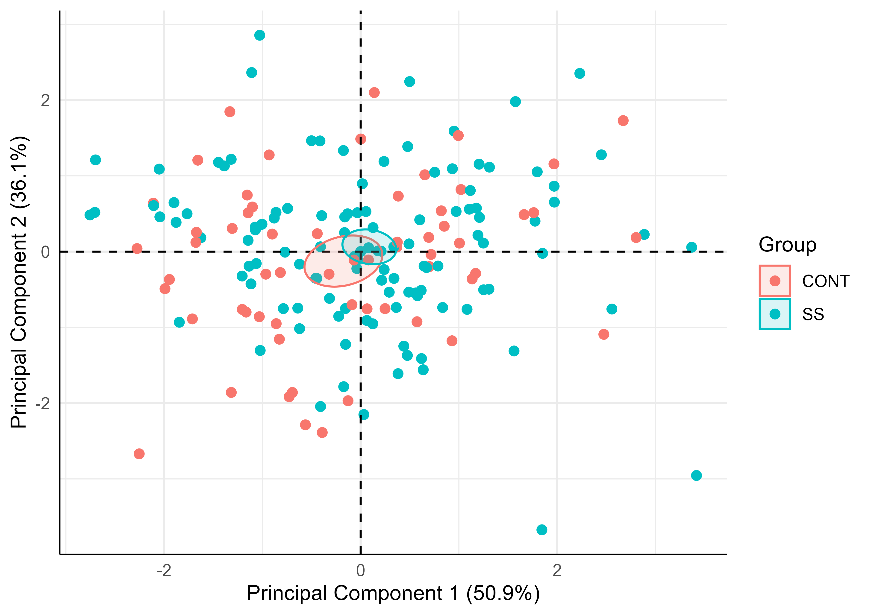

PCA Ellipse-Confidence

The 50.9% and 36.1% values in the axes of the figures above describe the percent variation in the data explained by the first and second principal components, respectively.

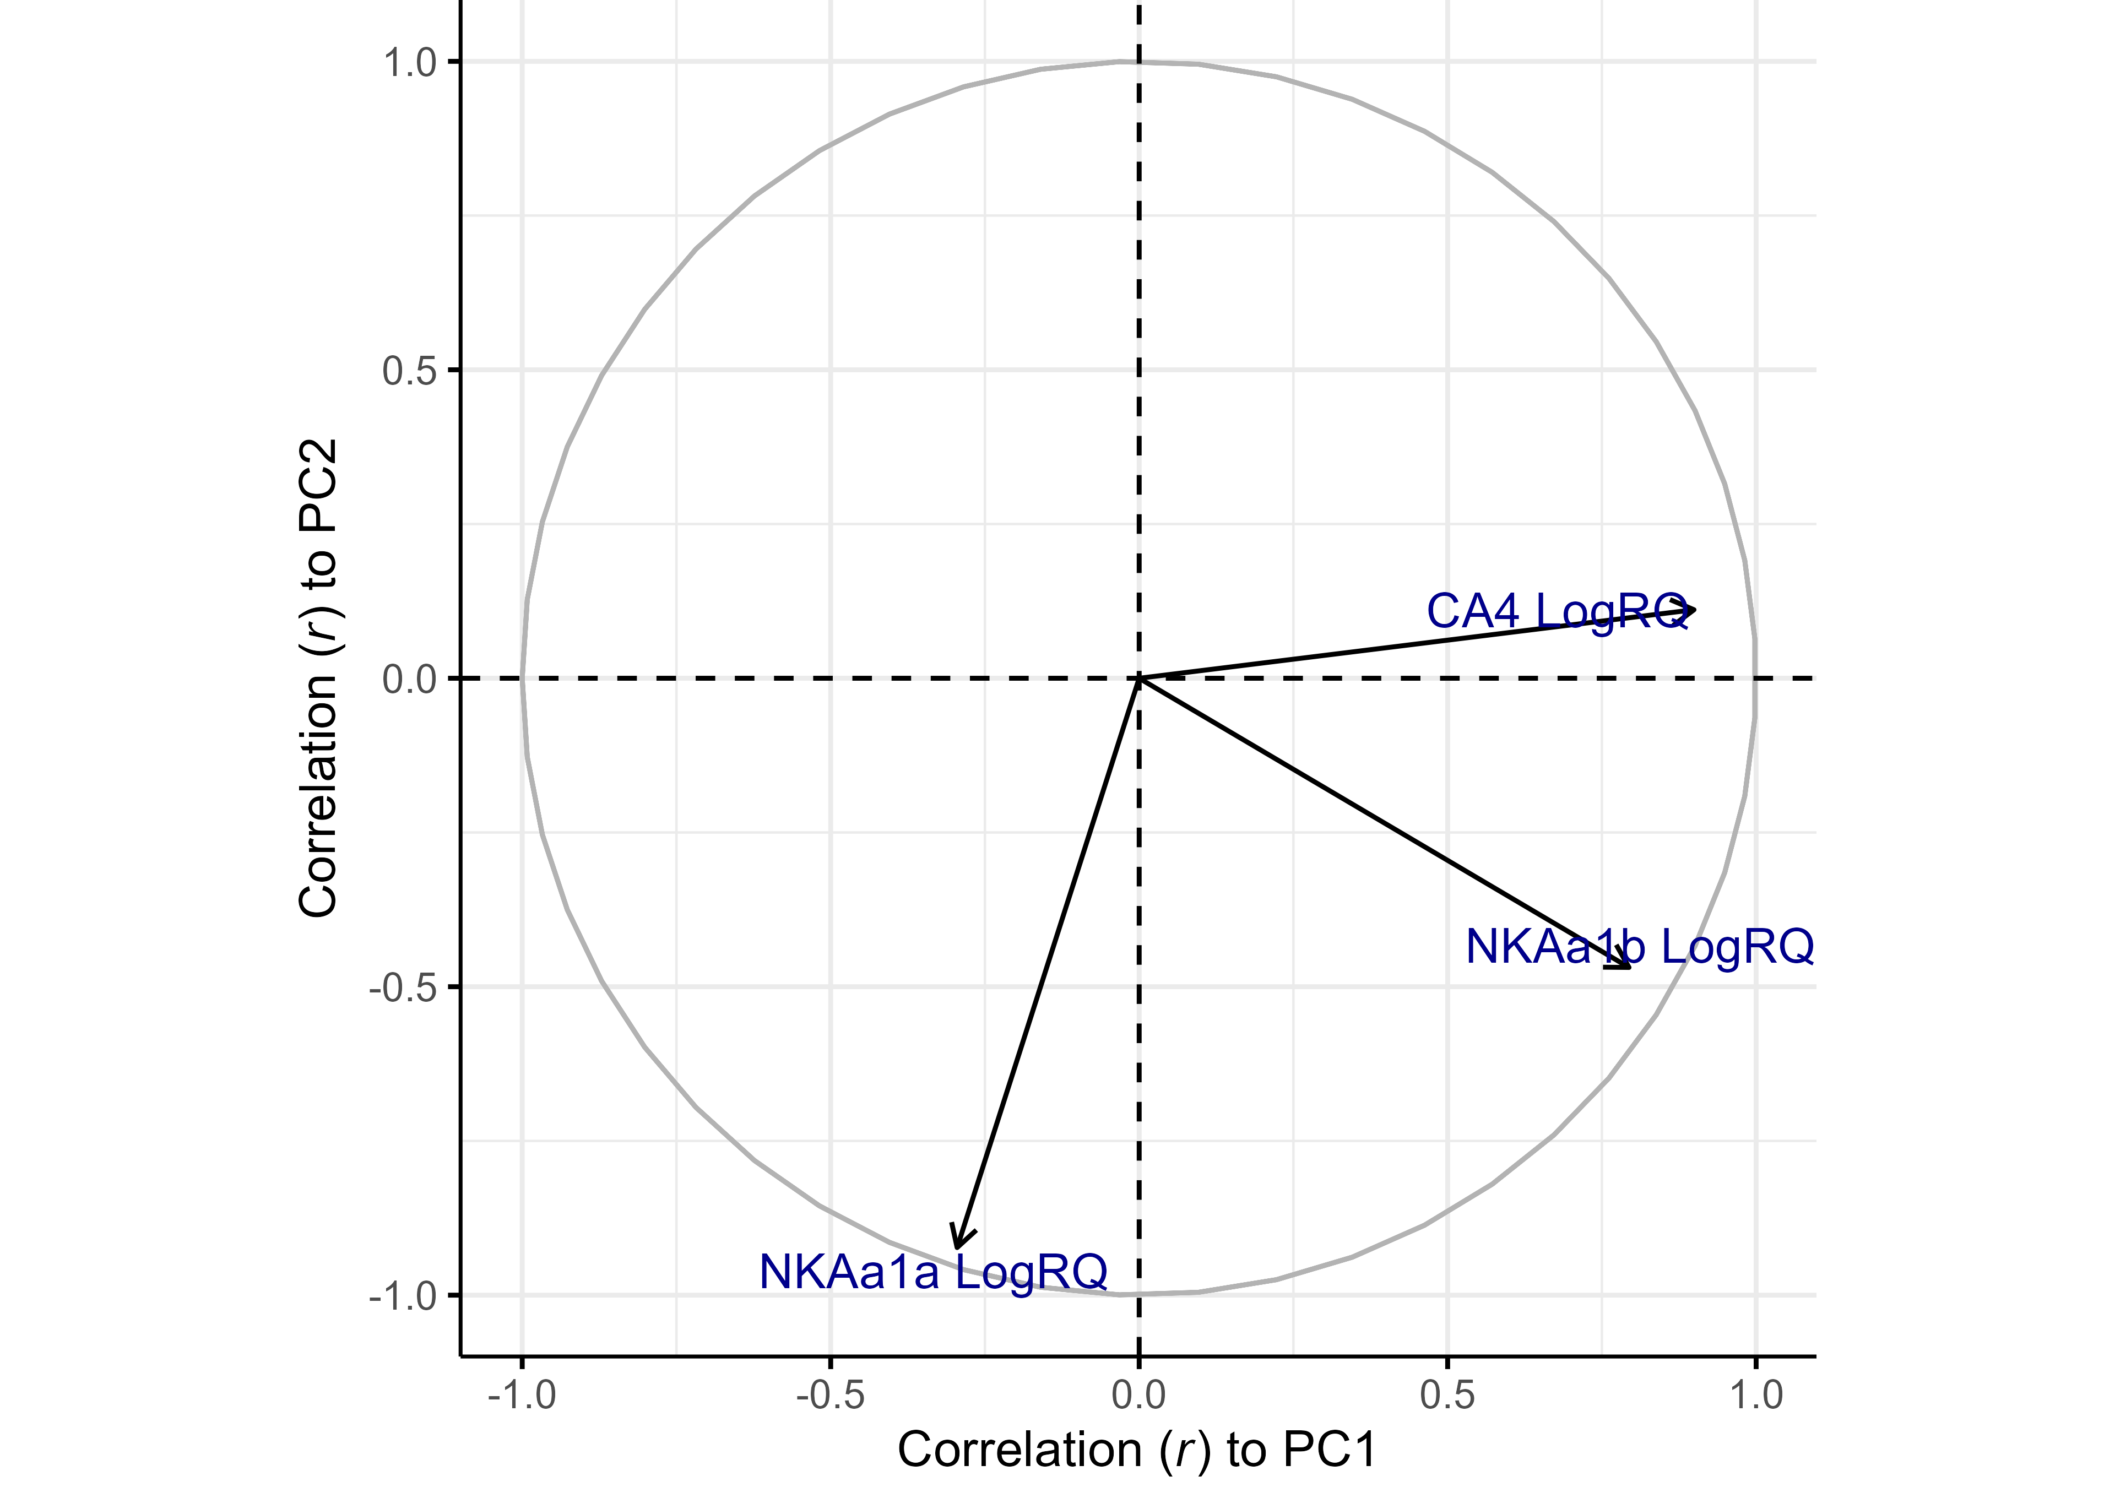

Correlation of Variables to PCs

## Statistical Tables

Table 1. Pearson correlation coefficient (r) between variables and principal components

|  | NKAa1a LogRQ | NKAa1b LogRQ | CA4 LogRQ | PC1 | PC2 |
| --- | --- | --- | --- | --- | --- |
| NKAa1a LogRQ | 1.0000 | 0.1025 | -0.2631 | -0.2951 | -0.9228 |
| NKAa1b LogRQ | 0.1025 | 1.0000 | 0.4982 | 0.7940 | -0.4688 |
| CA4 LogRQ | -0.2631 | 0.4982 | 1.0000 | 0.8993 | 0.1111 |
| PC1 | -0.2951 | 0.7940 | 0.8993 | 1.0000 | 0.0000 |
| PC2 | -0.9228 | -0.4688 | 0.1111 | 0.0000 | 1.0000 |

Table 2. Contribution of variables to principal components

| Variable | ContributionPC1 | EigenvectorPC1 | ContributionPC2 | EigenvectorPC2 |
| --- | --- | --- | --- | --- |
| CA4 LogRQ | 52.990235 | 0.7279439 | 1.138325 | 0.1066923 |
| NKAa1b LogRQ | 41.304503 | 0.6426858 | 20.277773 | -0.4503085 |
| NKAa1a LogRQ | 5.705262 | -0.2388569 | 78.583902 | -0.8864756 |

The contribution describes how much (in %) of the PC is composed of that variable; a more precise definition is that it is the variable's eigenvector^2 when the sum of eigenvectors^2 (over all variables) is equal to 1 (100%) for each PC (this condition is implicit in PCA). The eigenvector represents both the magnitude and direction of change of the principal component for each unit increase of the variable. This variable is in the standardized scale (z-score normalized) if scale and center arguments are set to TRUE.

Table 3. Contribution of variables to linear discriminants of Group

| Variable | ContributionLD1 | CoefficientLD1 |
| --- | --- | --- |
| CA4 LogRQ | 73.692877 | 0.8437797 |
| NKAa1a LogRQ | 21.801586 | -0.4589447 |
| NKAa1b LogRQ | 4.505537 | -0.2086362 |

LD1 and LD2 explain 100% and NA% of the separation between Group, respectively.

Tabulated values are based on Linear Discriminant Analysis (LDA). The contribution describes the percentage of the linear discriminant composed of that variable; a more exact definition is that it is the variable's coefficient of linear discriminant^2 when the sum of coefficients^2 (across variables) is normalized to 100%. The coefficient of linear discriminant describes the magnitude and direction of change in the linear discriminant score (towards a particular factor level) per unit increase of the variable. Apart from the coefficients relative signs and magnitude, they may be difficult to interpret without an associated LDA plot.

Table 4. MANOVA Results

| Factor | P_value |
| --- | --- |
| Group | 0.3267 |